**COURSE DESCRIPTION**

This course leads the students to the awareness on the following:

1. Ecological framework of sustainable development;
2. Pollution environments;
3. Water, air, and solid;
4. Waste treatment processes, disposal, and management;
5. Government legislation, rules, and regulation related to the environment and waste management; and
6. Environmental management system.

**LEARNING OUTCOMES**

At the end of the course, the student shall be able to:

* Gain consciousness on the various effects of environmental pollution.
* Familiarize oneself to the existing laws, rules, and regulations of the government on environmental issue.
* Indicate and manage the selected appropriate design treatment schemes for waste disposal.
* Have awareness of the importance of waste management and its relevance to the engineering profession.

**TOPIC OUTLINE**

* Ecological Concepts
* Biogeochemical Cycles
* The Nitrogen Cycle
* The Oxygen Cycle
* The Carbon Cycle
* The Water Cycle
* Phosphorus Cycle
* Sulfur Cycle

**MIDTERM**

**WEEKS 5 – MAJOR EXAM (PRELIMINARY)**

**WEEKS 6-8**

**INTRODUCTION**

Element in chemistry is being defined as a single atom and compound is made up of elements chemically combined in a definite proportion. A movement between these elements or compounds and its various living and non-living form and in consideration of the location in the biosphere is termed as ***Biogeochemical Cycles***. These cycles are known to be any of the natural pathways by which elements or atoms of living matter are circulated. The word biogeochemical refers to the consideration of the biological, geological, and chemical aspects of each cycle.

Let us find out more about this biogeochemical cycle and have knowledge and information of some of the different types of the said cycle in this module.

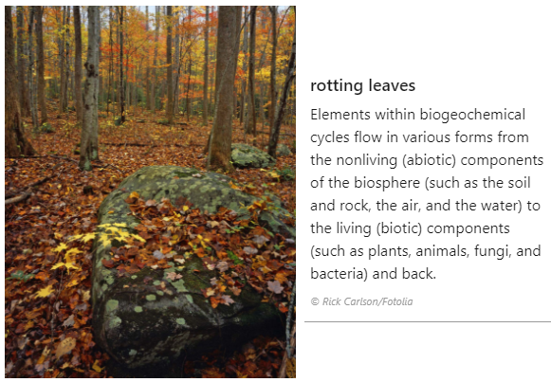

**TOPIC / LESSON**

* What is Biogeochemical Cycle
* Classification of Biogeochemical Cycles
* Different Types of Biogeochemical Cycles

**IMPORTANT TERMS**

1. Element = any substance that cannot be decomposed into simpler substances by ordinary
2. Compound = any substance composed of two or more chemical elements
3. Biosphere = a global ecosystem composed of living organisms (biotic) and the non-living factors (abiotic) from which they derive energy and nutrients
4. Cycle = any complete round of series of occurrences that repeats or is repeated

**IDEATION**

All biotic components of the biosphere aim for survival and in order to achieve this, a continuous recycle of all the chemical elements that make up living cells is necessary. Unlike energy which is flowing within the earth’s ecosystem enters in the form of sunlight and leaves in the form of heat. For the chemical components that make living organisms to keep alive, these are to be recycled.

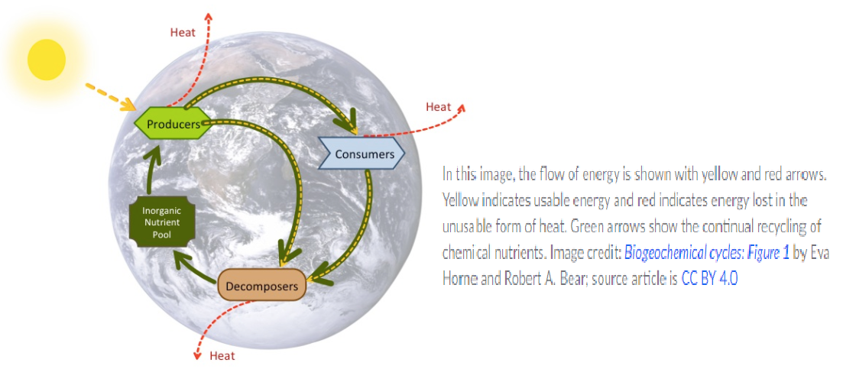

It has been studied that there are six common elements in organic molecules. These are the carbon, hydrogen, oxygen, nitrogen, phosphorus, and sulfur. These elements may be stored in the atmosphere, on land, in water, or even beneath the earth’s surface for a long or short period. These are also the elements that may be stored in the bodies of living organisms. Interactions among organisms as well as some geologic processes such as weathering of rocks, erosion, water drainage, and the subduction of continental plates play a role in the recycling of materials. ***Biogeochemical cycles*** come in with the ways in which an element or even other substances or compounds such as water when such things interact between its various living and non-living forms and location.

Biogeochemical cycles are being classified into two namely: 1) **Gaseous** in which the reservoir is the air or the oceans, that is via evaporation; and 2) **Sedimentary** in which the reservoir is earth’s crusts. Some type of cycles under each classification are the following:

***Gaseous cycles:***

1. Nitrogen Cycle
2. Oxygen Cycle
3. Carbon Cycle
4. Water Cycle

***Sedimentary cycles:***

1. Iron Cycle
2. Calcium Cycle
3. Phosphorus Cycle
4. Sulfur Cycle

The following are extracted from Britannica.com (see References)

***NITROGEN CYCLE:***

**Nitrogen cycle**, circulation of [nitrogen](https://www.britannica.com/science/nitrogen) in various forms through nature. Nitrogen, a component of [proteins](https://www.britannica.com/science/protein) and [nucleic acids](https://www.britannica.com/science/nucleic-acid), is essential to [life](https://www.britannica.com/science/life) on [Earth](https://www.britannica.com/place/Earth). Although 78 percent by volume of the [atmosphere](https://www.britannica.com/science/atmosphere) is nitrogen [gas](https://www.britannica.com/science/gas-state-of-matter), this abundant reservoir exists in a form unusable by most organisms. Through a series of microbial transformations, however, nitrogen is made available to [plants](https://www.britannica.com/plant/plant), which in turn ultimately sustain all [animal](https://www.britannica.com/animal/animal) life. The steps, which are not altogether sequential, fall into the following classifications: [nitrogen fixation](https://www.britannica.com/science/nitrogen-fixation), nitrogen assimilation, ammonification, nitrification, and [denitrification](https://www.britannica.com/science/denitrification).

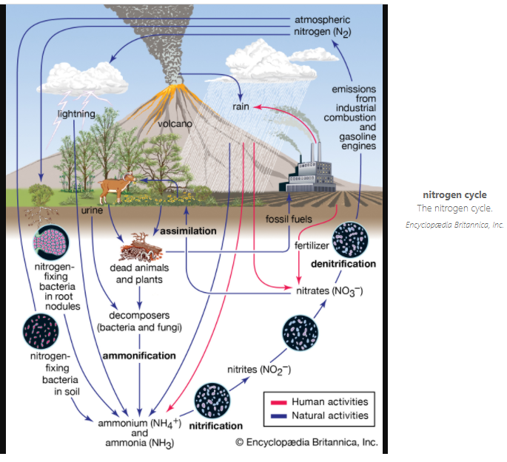

Nitrogen fixation, in which nitrogen gas is converted into inorganic nitrogen [compounds](https://www.britannica.com/science/chemical-compound), is mostly (90 percent) accomplished by certain [bacteria](https://www.britannica.com/science/bacteria) and [blue-green algae](https://www.britannica.com/science/blue-green-algae). A much smaller amount of free nitrogen is fixed by abiotic means (e.g., [lightning](https://www.britannica.com/science/lightning-meteorology), [ultraviolet radiation](https://www.britannica.com/science/ultraviolet-radiation), electrical equipment) and by conversion to [ammonia](https://www.britannica.com/science/ammonia) through the [Haber-Bosch process](https://www.britannica.com/technology/Haber-Bosch-process).

Nitrates and ammonia resulting from [nitrogen](https://www.britannica.com/science/nitrogen-assimilation) fixation are [assimilated](https://www.merriam-webster.com/dictionary/assimilated) into the specific [tissue](https://www.britannica.com/science/tissue) [compounds](https://www.merriam-webster.com/dictionary/compounds) of algae and higher plants. Animals then ingest these algae and plants, converting them into their own body compounds.

The remains of all living things—and their waste products—are decomposed by microorganisms in the process of [ammonification](https://www.britannica.com/science/ammonification), which yields ammonia (NH3) and ammonium (NH4+). (Under anaerobic, or oxygen-free, conditions, foul-smelling putrefactive products may appear, but they too are converted to ammonia in time.) Ammonia can leave the [soil](https://www.britannica.com/science/soil) or be converted into other nitrogen compounds, depending in part on soil conditions.

[Nitrification](https://www.britannica.com/science/nitrification), a process carried out by [nitrifying bacteria](https://www.britannica.com/science/nitrifying-bacterium), transforms soil ammonia into [nitrates](https://www.britannica.com/science/nitrate) (NO3−), which plants can incorporate into their own tissues.

[Nitrates](https://www.britannica.com/science/nitrate) also are metabolized by [denitrifying bacteria](https://www.britannica.com/science/denitrifying-bacteria), which are especially active in water-logged anaerobic soils. The action of these bacteria tends to deplete soil nitrates, forming free atmospheric nitrogen.

***OXYGEN CYCLE:***

**Oxygen cycle**, circulation of [oxygen](https://www.britannica.com/science/oxygen) in various forms through nature. Free in the air and dissolved in water, oxygen is second only to nitrogen in abundance among uncombined elements in the atmosphere. Plants and animals use oxygen to respire and return it to the air and water as [carbon dioxide](https://www.britannica.com/science/carbon-dioxide) (CO2). CO2 is then taken up by algae and terrestrial green plants and converted into carbohydrates during the process of [photosynthesis](https://www.britannica.com/science/photosynthesis), oxygen being a by-product. The waters of the world are the main oxygen generators of the biosphere; their algae are estimated to replace about 90 percent of all oxygen used. Oxygen is involved to some degree in all the other biogeochemical cycles. For example, over time, [detritus](https://www.merriam-webster.com/dictionary/detritus) from living organisms transfers oxygen-containing [compounds](https://www.merriam-webster.com/dictionary/compounds) such as calcium carbonates into the lithosphere.

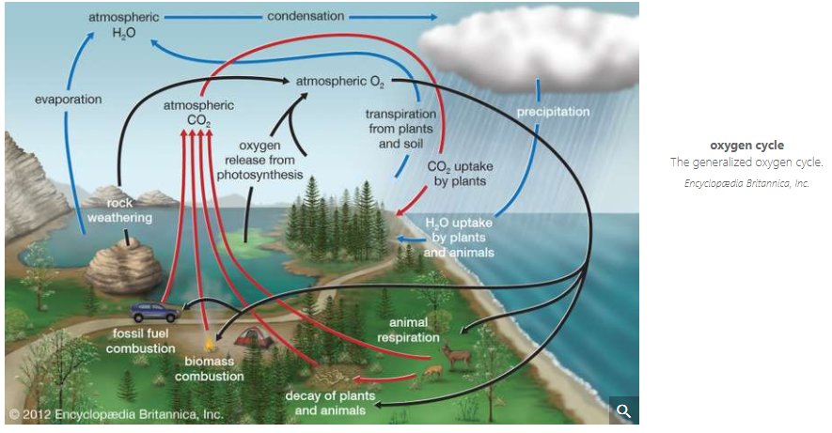

Despite the burning of [fossil fuel](https://www.britannica.com/science/fossil-fuel) and the reduction of natural vegetation (on land and in the sea), the level of atmospheric oxygen appears to be relatively stable because of the increase in plant productivity resulting from agricultural advances worldwide.

***CARBON CYCLE:***

**Carbon cycle**, in biology, circulation of carbon in various forms through nature. Carbon is a [constituent](https://www.merriam-webster.com/dictionary/constituent) of all organic [compounds](https://www.merriam-webster.com/dictionary/compounds), many of which are essential to life on [Earth](https://www.britannica.com/place/Earth). The source of the carbon found in living matter is [carbon dioxide](https://www.britannica.com/science/carbon-dioxide) (CO2) in the air or dissolved in water. Algae and terrestrial green plants ([producers](https://www.britannica.com/science/producer-biology)) are the chief agents of carbon dioxide fixation through the process of [photosynthesis](https://www.britannica.com/science/photosynthesis), through which carbon dioxide and water are converted into simple carbohydrates. These compounds are used by the producers to carry on metabolism, the excess being stored as fats and [polysaccharides](https://www.britannica.com/science/polysaccharide). The stored products are then eaten by consumer organisms, from protozoans to man, which convert them into other forms. CO2 is added directly to the [atmosphere](https://www.britannica.com/science/atmosphere) by animals and some other organisms as a by-product of respiration. The carbon present in animal wastes and in the bodies of all organisms is released as CO2 by decay, or [decomposer](https://www.britannica.com/science/decomposer), organisms (chiefly bacteria and fungi) in a series of microbial transformations.

[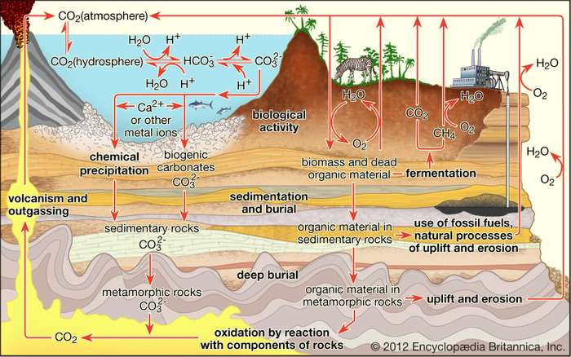](https://cdn.britannica.com/20/24020-050-1530CF62/carbon-cycle-Carbon-atmosphere-hydrosphere-forms-formations.jpg)

Carbon is transported in various forms through the atmosphere, the hydrosphere, and geologic formations. One of the primary pathways for the exchange of carbon dioxide (CO2) takes place between the atmosphere and the oceans; there a fraction of the CO2 combines with water, forming carbonic acid (H2CO3) that subsequently loses hydrogen ions (H+) to form bicarbonate (HCO3−) and carbonate (CO32−) ions. Mollusk shells or mineral precipitates that form by the reaction of calcium or other metal ions with carbonate may become buried in geologic strata and eventually release CO2 through volcanic outgassing. Carbon dioxide also exchanges through photosynthesis in plants and through respiration in animals. Dead and decaying organic matter may ferment and release CO2 or methane (CH4) or may be incorporated into sedimentary rock, where it is converted to fossil fuels. Burning of hydrocarbon fuels returns CO2 and water (H2O) to the atmosphere. The biological and anthropogenic pathways are much faster than the geochemical pathways and, consequently, have a greater impact on the composition and temperature of the atmosphere. *Encyclopædia Britannica, Inc.*

Part of the organic carbon—the remains of organisms—has accumulated in Earth’s crust as [fossil fuels](https://www.britannica.com/science/fossil-fuel) (e.g., coal, gas, and petroleum), [limestone](https://www.britannica.com/science/limestone), and coral. The carbon of fossil fuels, removed from the cycle in prehistoric time, is now being released in vast amounts as CO2 through industrial and agricultural processes, much of it quickly passing into the oceans and there being “fixed” as carbonates. If oxygen is scarce (as in sewage, marshes, and swamps), some carbon is released as [methane](https://www.britannica.com/science/methane) gas.

***WATER CYLCE:***

**Water cycle**, also called **hydrologic cycle**, cycle that involves the continuous circulation of water in the Earth-atmosphere system. Of the many processes involved in the water cycle, the most important are evaporation, transpiration, condensation, precipitation, and runoff. Although the total amount of water within the cycle remains essential constant, its distribution among the various processes is continually changing.

[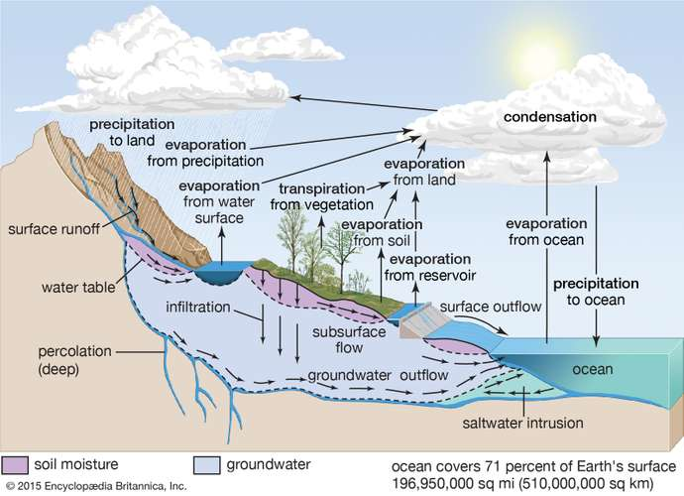](https://cdn.britannica.com/89/62689-050-BD53B2F5/water-hydrologic-cycle-land-surface-atmosphere-ocean.jpg)

In the hydrologic cycle, water is transferred between the land surface, the ocean, and the atmosphere. *Encyclopædia Britannica, Inc.*

[Evaporation](https://www.britannica.com/science/evaporation), one of the major processes in the cycle, is the transfer of water from the surface of the Earth to the atmosphere. By evaporation, water in the [liquid](https://www.britannica.com/science/liquid-state-of-matter) state is transferred to the [gaseous](https://www.britannica.com/science/gas-state-of-matter), or vapour, state. This transfer occurs when some molecules in a [water mass](https://www.britannica.com/science/water-mass) have attained sufficient [kinetic energy](https://www.britannica.com/science/kinetic-energy) to eject themselves from the water surface. The main factors affecting evaporation are [temperature](https://www.britannica.com/science/temperature), [humidity](https://www.britannica.com/science/humidity), [wind](https://www.britannica.com/science/wind) speed, and [solar radiation](https://www.britannica.com/science/solar-radiation). The direct measurement of evaporation, though desirable, is difficult and possible only at point locations. The principal source of water vapour is the [oceans](https://www.britannica.com/science/ocean), but evaporation also occurs in [soils](https://www.britannica.com/science/soil), [snow](https://www.britannica.com/science/snow-weather), and [ice](https://www.britannica.com/science/ice). Evaporation from snow and ice, the direct conversion from [solid](https://www.britannica.com/science/solid-state-of-matter) to vapour, is known as sublimation. [Transpiration](https://www.britannica.com/science/transpiration) is the evaporation of water through minute pores, or stomata, in the leaves of [plants](https://www.britannica.com/plant/plant). For practical purposes, transpiration and the evaporation from all water, soils, snow, ice, vegetation, and other surfaces are lumped together and called [evapotranspiration](https://www.britannica.com/science/evapotranspiration), or total evaporation.

[Water vapour](https://www.britannica.com/science/water-vapor) is the primary form of atmospheric moisture. Although its storage in the atmosphere is comparatively small, water vapour is extremely important in forming the moisture supply for [dew](https://www.britannica.com/science/dew), [frost](https://www.britannica.com/science/frost-meteorology), [fog](https://www.britannica.com/science/fog), [clouds](https://www.britannica.com/science/cloud-meteorology), and precipitation.

The transition process from the vapour state to the [liquid](https://www.britannica.com/science/liquid-state-of-matter) state is called [condensation](https://www.britannica.com/science/condensation-phase-change). Condensation may take place as soon as the [air](https://www.britannica.com/science/air) contains more water vapour than it can receive from a free water surface through evaporation at the prevailing temperature. This condition occurs as the consequence of either cooling or the mixing of air masses of different temperatures. By condensation, water vapour in the atmosphere is released to form [precipitation](https://www.britannica.com/science/precipitation).

Precipitation that falls to the Earth is distributed in four main ways: some is returned to the atmosphere by evaporation, some may be intercepted by vegetation and then evaporated from the surface of [leaves](https://www.britannica.com/science/leaf-plant-anatomy), some [percolates](https://www.merriam-webster.com/dictionary/percolates) into the [soil](https://www.britannica.com/science/soil) by infiltration, and the remainder flows directly as surface [runoff](https://www.britannica.com/science/runoff) into the sea. Some of the infiltrated precipitation may later [percolate](https://www.merriam-webster.com/dictionary/percolate) into streams as [groundwater](https://www.britannica.com/science/groundwater) runoff. Direct measurement of runoff is made by stream gauges and plotted against time on hydrographs.

[Ice](https://www.britannica.com/science/ice) also plays a role in the water cycle. Ice and snow on the Earth’s surface occur in various forms such as frost, [sea ice](https://www.britannica.com/science/sea-ice), and [glacier](https://www.britannica.com/science/glacier) ice. When soil moisture freezes, ice also occurs beneath the Earth’s surface, forming [permafrost](https://www.britannica.com/science/permafrost) in [tundra climates](https://www.britannica.com/science/tundra-climate). About 18,000 years ago glaciers and ice caps covered approximately one-third of the Earth’s land surface. Today about 12 percent of the land surface remains covered by ice masses.

***PHOSPHORUS CYCLE:***

**Phosphorus cycle**, circulation of [phosphorus](https://www.britannica.com/science/phosphorus-chemical-element) in various forms through nature. Of all the elements recycled in the [biosphere](https://www.britannica.com/science/biosphere), phosphorus is the scarcest and therefore the one most limiting in any given ecological system. It is indispensable to life, being intimately involved in [energy transfer](https://www.britannica.com/science/energy-flow) and in the passage of genetic information in the deoxyribonucleic acid ([DNA](https://www.britannica.com/science/DNA)) of all cells.

[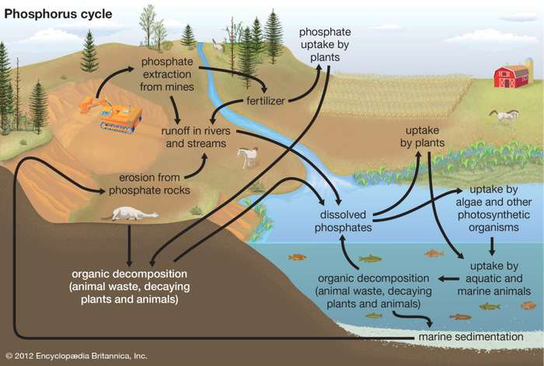](https://cdn.britannica.com/77/126077-050-117592F5/Phosphorus-environments-growth-plants-elements.jpg)

Phosphorus, which cycles primarily through the terrestrial and aquatic environments, is one of the most-important elements influencing the growth of plants. *Encyclopædia Britannica, Inc.*

Much of the phosphorus on Earth is tied up in rock and sedimentary deposits, from which it is released by [weathering](https://www.britannica.com/science/weathering-geology), leaching, and mining. Some of it passes through freshwater and terrestrial ecosystems via plants, grazers, predators, and parasites, to be returned to those ecosystems by death and decay. Much of it, however, is deposited in the sea, in shallow sediments, where it circulates readily, or in [ocean](https://www.britannica.com/science/ocean) deeps, whence it wells up only occasionally. Phosphorus is brought back to the land through fish harvests and through collection of guano deposited by seabirds. Although there are seasonal pulses of availability, there appears to be a steady loss of phosphorus to the ocean deeps.

Because of its high reactivity, phosphorus exists in combined form with other elements. Microorganisms produce acids that form soluble phosphate from insoluble phosphorus [compounds](https://www.merriam-webster.com/dictionary/compounds). The phosphates are utilized by algae and terrestrial green plants, which in turn pass into the bodies of animal consumers. Upon death and decay of organisms, phosphates are released for recycling.

Because of the steady diversion of phosphorus into the oceans, the element must be added (in fertilizers) to soils to maintain fertility and agricultural productivity.

***SULFUR CYCLE:***

**Sulfur cycle**, circulation of [sulfur](https://www.britannica.com/science/sulfur) in various forms through nature. Sulfur occurs in all living matter as a component of certain [amino acids](https://www.britannica.com/science/amino-acid). It is abundant in the soil in [proteins](https://www.britannica.com/science/protein) and, through a series of microbial transformations, ends up as [sulfates](https://www.britannica.com/science/sulfate) usable by plants.

[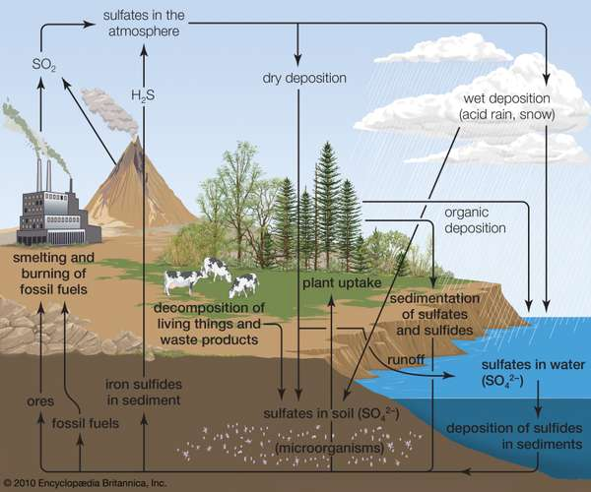](https://cdn.britannica.com/37/112537-050-7F7829C5/sedimentary-rocks-sources-human-hydrogen-sulfide-gas.jpg)

**sulfur cycle**Major sulfur-producing sources include sedimentary rocks, which release hydrogen sulfide gas, and human sources, such as smelters and fossil-fuel combustion, both of which release sulfur dioxide into the atmosphere.*Encyclopædia Britannica, Inc.*

Sulfur-containing proteins are degraded into their [constituent](https://www.merriam-webster.com/dictionary/constituent) amino acids by the action of a variety of soil organisms. The sulfur of the amino acids is converted to [hydrogen sulfide](https://www.britannica.com/science/hydrogen-sulfide) (H2S) by another series of soil microbes. In the presence of oxygen, H2S is converted to sulfur and then to [sulfate](https://www.britannica.com/science/sulfate) by [sulfur bacteria](https://www.britannica.com/science/sulfur-bacterium). Eventually the sulfate becomes H2S.

Hydrogen sulfide rapidly oxidizes to gases that dissolve in water to form [sulfurous](https://www.britannica.com/science/sulfurous-acid) and [sulfuric acids](https://www.britannica.com/science/sulfuric-acid). These [compounds](https://www.merriam-webster.com/dictionary/compounds) contribute in large part to the “[acid rain](https://www.britannica.com/science/acid-rain)” that can kill sensitive aquatic organisms and damage marble monuments and stone buildings.

**ACTIVITY**

Video Activity: Watch the following YouTube videos and give the summary of each.

🡺 Biogeochemical cycles I Ecology I Khan Academy

https://youtu.be/ccWUDlKC3dE

🡺 The water cycle I Ecology I Khan Academy

<https://youtu.be/jFjI6y46QRk>

🡺 The carbon cycle I Ecology I Khan Academy

<https://youtu.be/_dYkByQ9Kmg>

🡺 The nitrogen cycle I Ecology I Khan Academy

<https://youtu.be/DsCMYyQ0NWU>

🡺 Phosphorus cycle I Ecology I Khan Academy

<https://youtu.be/tm2LG5ScT1g>

**WRAPPING UP**

1. Elements stated in this module are Carbon, Oxygen, Phosphorus, Sulfur, and Nitrogen. With the use of the Periodic Table of Elements (PTE), give the following for these elements:
2. Chemical Symbol
3. Atomic Number
4. Mass Number/Atomic Weight
5. Kind of Element
6. Number of electrons
7. Number of protons
8. Make a research on the other two types of Sedimentary Biogeochemical Cycles:
9. Iron Cycle
10. Calcium Cycle
11. Prepare a short write-up/summary of the videos on biogeochemical cycles and its types assigned to you to watch (see Activity)

**REFERENCES**

1. Editors of Encyclopædia Britannica, ©2020 Encyclopædia Britannica, Inc., *Biogeochemical cycle.* Retrieved from <https://www.britannica.com/science/biogeochemical-cycle>
2. Editors of Encyclopædia Britannica, Revised and updated by John P. Refferty, ©2020 Encyclopædia Britannica, Inc., *Nitrogen cycle.* Retrieved from <https://www.britannica.com/science/nitrogen-cycle>
3. Editors of Encyclopædia Britannica, Revised and updated by John P. Refferty, ©2020 Encyclopædia Britannica, Inc., *Oxygen cycle.* Retrieved from <https://www.britannica.com/science/oxygen-cycle>
4. Editors of Encyclopædia Britannica, Revised and updated by Michele Metych, ©2020 Encyclopædia Britannica, Inc., *Carbon cycle.* Retrieved from <https://www.britannica.com/science/carbon-cycle>
5. Editors of Encyclopædia Britannica, Revised and updated by John P. Refferty, ©2020 Encyclopædia Britannica, Inc., *Water cycle.* Retrieved from <https://www.britannica.com/science/water-cycle>
6. Editors of Encyclopædia Britannica, Revised and updated by Amy Tikkanen, ©2020 Encyclopædia Britannica, Inc., *Phosphorus cycle.* Retrieved from <https://www.britannica.com/science/phosphorus-cycle>
7. Editors of Encyclopædia Britannica, Revised and updated by Adam Augustyn, ©2020 Encyclopædia Britannica, Inc., *Sulfur cycle.* Retrieved from <https://www.britannica.com/science/sulfur-cycle>
8. J.J. Lagowski, ©2020 Encyclopædia Britannica, Inc., *Chemical element.* Retrieved from <https://www.britannica.com/science/chemical-element>
9. Richard O.C. Norman, ©2020 Encyclopædia Britannica, Inc., *Chemical compound.* Retrieved from <https://www.britannica.com/science/chemical-compound>
10. Khan Academy, ©2020 Khan Academy, Intro to biogeochemical cycles. Retrieved from <https://www.khanacademy.org/science/biology/ecology/biogeochemical-cycles/a/introduction-to-biogeochemical-cycles>
11. David M. Gates, ©2020 Encyclopædia Britannica, Inc., *Biosphere.* Retrieved from <https://www.britannica.com/science/biosphere>
12. DICTIONARY.COM, ©2020 Dictionary.com, LLC*.* *Cycle*. Retrieved from <https://www.dictionary.com/browse/cycle>